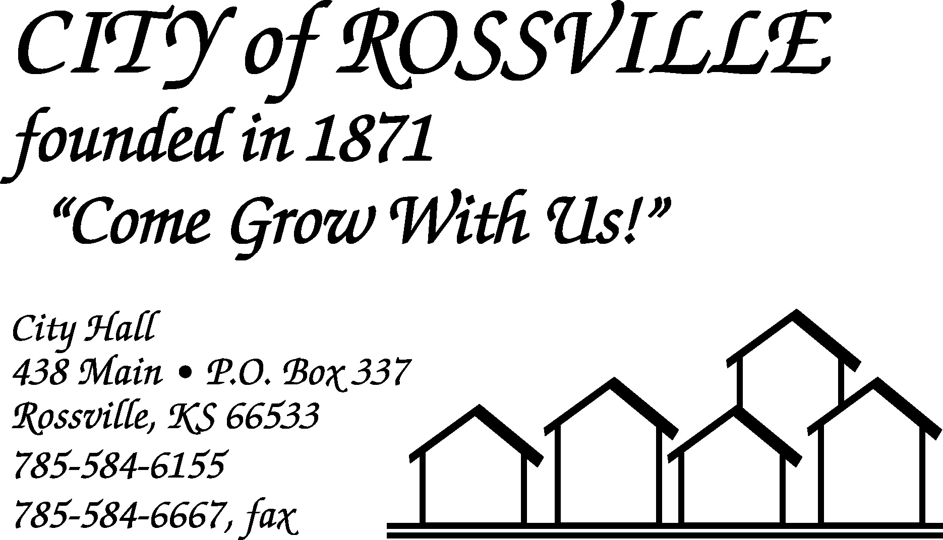

City Hall June 6, 2022

The Rossville City Council meeting was called to order on Monday, June 6, 2022 at 6:00 pm by Mayor James Meyer.

Council members present were Todd Reeves, Trish Heim and Toby McCullough. Dan Glotzbach was absent.

Also present was Brad Kirk, Jason Connell, Jon Thederahn, Brandon Mildren, Nate Wood, and Taylor Morelli.

Motion by Trish Heim to approve minutes of the May 16, 2022 meeting as written was seconded by Toby McCullough and carried.

The following bills were presented;

Titan Cleaning Services $ 560.00 Alan Zlatnik $1,720.55
EFTPS-Fed WH $ 1,086.69 Tracey Taylor $ 858.23
EFPTS-FICA $ 2,087.60 EMPower Retirement $ 447.00
Lisa Stum $ 1,312.96 Michael Kirk $1,273.19
Grace Hier $ 150.00 Kansas Payment Center $ 123.69
Randall Anderson $ 997.20 Douglas Schreiner $ 221.91
Kansas Withholding Tax $ 529.60 Jason Connell $1,052.53
KP&F $ 1,252.64 Harry Hammer $ 242.75
KPERS $ 1,406.46 Tina Dick $ 492.05
Trent Stanley $ 1,479.41 Jacob Akin $ 103.78
AT&T $ 408.14 Amazon $ 126.94
Bank of Flint Hills $ 43.30 Courtyard by Marriott $1,251.05
Wehner’s Thriftway $ 222.93 AFLAC $ 490.28
Wheatland Pest Control $ 180.00 Caseys Business Mastercard $1,411.79
World Insurance Associates $ 403.00 WTC $ 998.88
Crystal City Sports Pub $ 49.47 KCI Airport $ 45.00
League of KS Munic. $ 65.00 Los Tios Grill $ 37.29
Reservoir $ 37.63 Yahoo $ 23.99
Alan Streit $ 507.92 James Meyer $ 554.10
A Bargain Tree Service $15,000.00 Aramark $ 147.90
D&D Security $ 24.95 Dougs Pharmacy $ 9.47
GALLS LLC $ 71.56 Hawkins $1,777.09
LindySpring Systems $ 74.72 Lisa Stum $ 33.33
Lowes Business Account $ 235.78 MARC $ 723.68
Menards $ 285.34 Municipal Supply $ 545.60
National Sign Co $ 59.90 National Sign Co $ 59.90
RDR Excavating $ 796.00 Rossville Auto Supply $ 77.93
Schulte Supply Inc. $ 3,892.17 Sound Products Inc. $ 582.30
State Industrial Products $ 555.32 Tarwater Farm & Home $ 16.40
TOTAL $49,164.39

Motion by Toby McCullough to pay bills as presented totaling $49,164.39 was seconded by Todd Reeves and carried.

Motion by Toby McCullough to approve agenda with the addition of Brandon Mildren was seconded by Trish Heim and carried.

Jon Thederahn was present to inquire as to why a sidewalk was not present near the duplexes on Griswold St. Issue will be researched more to see who actually owns the lot.

Brandon Mildren and Nate Wood were present to follow up on the proposed use of the property next to Wehner’s Thriftway. Council decided zoning was ok. They will not be building for about 5 years.

Brad Kirk reported for the utility department. Water tower is full. Samples are being taken and sent to KDHE for testing. Tower should be back in use later this week.

Chief Jason Connell reported that code enforcement will be starting soon.

Council went into executive session at 6:42 pm for 30 minutes, 7:12 pm, for salary discussions.

Salary review was tabled until next council meeting.

Refund of fireworks stand permit was tabled until next council meeting.

Toby McCullough moved to accept the drinking establishment license for Fastdraws with a second by Todd Reeves. Motion carried.

Water bill adjustment was requested for 312 Navarre St. Toby McCullough moved to adjust the water bill. Trish Heim seconded. Motion carried.

Motion by Todd Reeves to adjourn was seconded by Trish Heim and carried. Meeting adjourned at 7:40 pm.

Asst City Clerk
Tracey L Taylor

